# Testing the VideoViewer program (and classes)

For validating the program, a few inputs are used to check whether it responds as it is meant to or not.

For such an activity, **3** different test cases are used to verify the functionality of the system.

## Test 1: creating Movie objects:

To create a Movie object, the following parameters have to be passed on:

Parameters inherited from the parent class “Video”.

* Title : string
* Description : string
* Duration : integer
* Image url : string
* Youtube url : string

Additional parameters inherited from the child class “Movie”.

* Director : string
* Year released : integer
* Rating : string

Avengers = video.Movie(**"The Avengers"**,  
 **"Earth's mightiest heroes must come together and learn to fight as a team if they are to stop the mischievous Loki and his alien army from enslaving humanity."**,  
 143,  
 **"Joss Whedon"**,  
 2012,  
 **"PG-13"**,  
 **"http://ia.media-imdb.com/images/M/MV5BMTk2NTI1MTU4N15BMl5BanBnXkFtZTcwODg0OTY0Nw@@._V1_SX640_SY720_.jpg"**,  
 **"https://www.youtube.com/watch?v=eOrNdBpGMv8"**)

Avengers.showInfo()

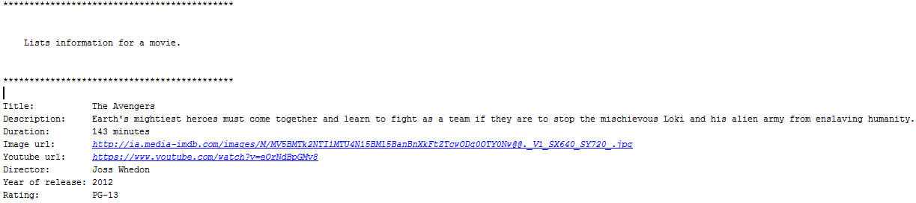

Figure 1: executing 'showInfo' for Avengers movie

DarkKnight = video.Movie(**"The Dark Knight"**,  
 **"When the menace known as the Joker wreaks havoc and chaos on the people of Gotham, the caped crusader must come to terms with one of the greatest psychological tests of his ability to fight injustice."**,  
 152,  
 **"Christopher Nolan"**,  
 2008,  
 **"PG-13"**,  
 **"http://ia.media-imdb.com/images/M/MV5BMTMxNTMwODM0NF5BMl5BanBnXkFtZTcwODAyMTk2Mw@@._V1_UY1200_CR90,0,630,1200_AL_.jpg"**,  
 **"https://www.youtube.com/watch?v=EXeTwQWrcwY"**)

DarkKnight.showInfo()

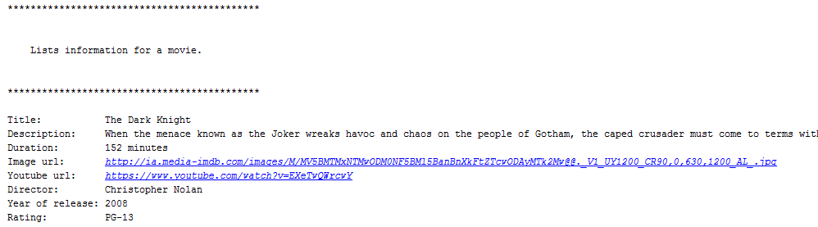

Deadpool = video.Movie(**"Deadpool"**,  
 **"A former Special Forces operative turned mercenary is subjected to a rogue experiment that leaves him with accelerated healing powers, adopting the alter ego Deadpool."**,  
 108,  
 **"Tim Miller"**,  
 2016,  
 **"R"**,  
 **"http://i.newsarama.com/images/i/000/162/257/i02/deadpool-ver9-11e99.jpg?1452784920"**,  
 **"https://www.youtube.com/watch?v=gtTfd6tISfw"**)

Deadpool.showInfo()

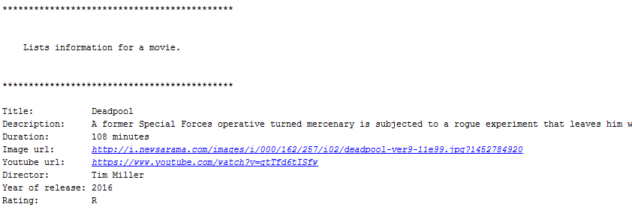

GuardiansOfTheGalaxy = video.Movie(**"Guardians of the Galaxy"**,  
 **"A group of intergalactic criminals are forced to work together to stop a fanatical warrior from taking control of the universe."**,  
 121,  
 **"James Gunn"**,  
 2014,  
 **"PG-13"**,  
 **"http://cdn.collider.com/wp-content/uploads/guardians-of-the-galaxy-movie-poster1.jpg"**,  
 **"https://www.youtube.com/watch?v=B16Bo47KS2g"**)

GuardiansOfTheGalaxy.showInfo()

## 

## Test 2: creating TV Show objects:

Arrow = video.TVSeries(**"Arrow"**,  
 **"young vampire hunter"**,  
 42,  
 **"Greg Berlanti"**,  
 2012,  
 4,  
 10,  
 **"http://ia.media-imdb.com/images/M/MV5BMTg3OTc0NzkyOV5BMl5BanBnXkFtZTgwMDMwMTM3MjE@._V1_UY1200_CR80,0,630,1200_AL_.jpg"**,  
 **"https://www.youtube.com/watch?v=2q3l4fMVCO8"**)

Arrow.showInfo()

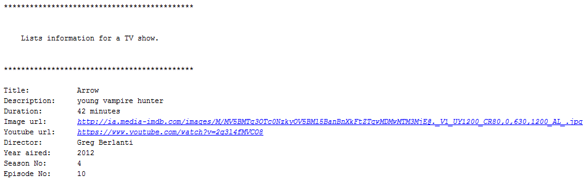

Buffy = video.TVSeries(**"Buffy the Vampire Slayer"**,  
 **"A young girl, destined to slay vampires, demons and other infernal creatures, deals with her life fighting evil, with the help of her friends."**,  
 44,  
 **"Joss Whedon"**,  
 1997,  
 1,  
 12,  
 **"http://fontmeme.com/images/Buffy-the-Vampire-Slayer-TV-Series.jpg"**,  
 **"https://www.youtube.com/watch?v=-1v_q6TWAL4"**)

Buffy.showInfo()

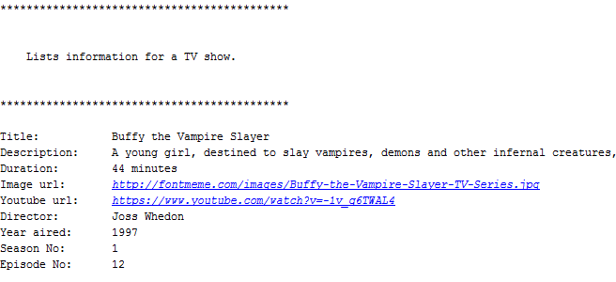  
  
Flash = video.TVSeries(**"The Flash"**,  
 **"Barry Allen wakes up 9 months after he was struck by lightning and discovers that the bolt gave him the power of super speed. With his new team and powers, Barry becomes 'The Flash' and fights crime in Central City."**,  
 43,  
 **"Greg Berlanti"**,  
 2014,  
 2,  
 9,  
 **"http://ia.media-imdb.com/images/M/MV5BNjAwNzkxNzAwNF5BMl5BanBnXkFtZTgwODg2NTc2NjE@._V1_UY1200_CR164,0,630,1200_AL_.jpg"**,  
 **"https://www.youtube.com/watch?v=UMRBs0-OXCA"**)

Flash.showInfo()

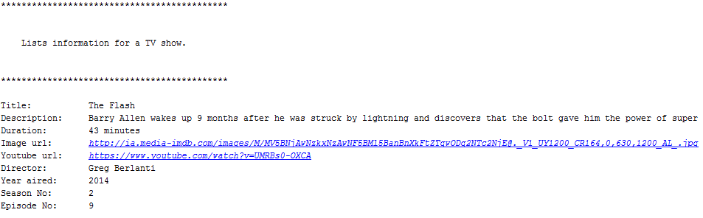

ModernFamily = video.TVSeries(**"Modern Family"**,  
 **"Three different, but related families face trials and tribulations in their own uniquely comedic ways."**,  
 22,  
 **"Steven Levitan"**,  
 2009,  
 5,  
 12,  
 **"http://ecx.images-amazon.com/images/I/51S2zWtsh1L._AC_UL320_SR232,320_.jpg"**,  
 **"https://www.youtube.com/watch?v=aogZUDx51vQ"**)

ModernFamily.showInfo()

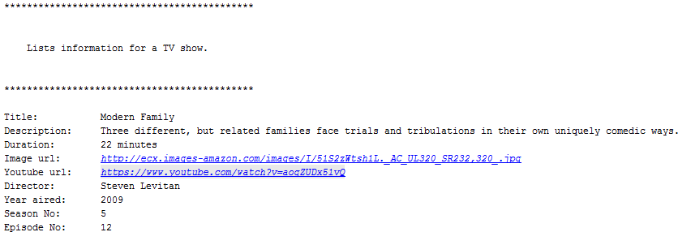

## Entering an invalid value

To ensure that the system only accepts valid inputs, it will be tested by entering some erroneous values, such as inputting name without quotes for a movie object.

Avengers = video.Movie(The Avengers,  
 **"Earth's mightiest heroes must come together and learn to fight as a team if they are to stop the mischievous Loki and his alien army from enslaving humanity."**,  
 143,  
 **"Joss Whedon"**,  
 2012,  
 **"PG-13"**,  
 **"http://ia.media-imdb.com/images/M/MV5BMTk2NTI1MTU4N15BMl5BanBnXkFtZTcwODg0OTY0Nw@@._V1_SX640_SY720_.jpg"**,  
 **"https://www.youtube.com/watch?v=eOrNdBpGMv8"**)

Avengers.showInfo()



The system indicates a sysntax error, since the title wasn’t passed as a string, because it wasn’t passed between quote marks.

## Creating a Category for the movie list.

At the end of the program, the program executes “webpagecreator.py” to display the objects created previously in a web browser, and display them based on the genre.

To do so the following parameters are passed on in “videoViewer.py”:

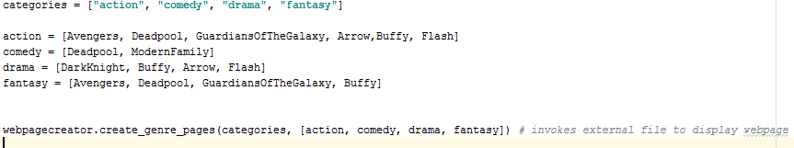

Categories are created using an array.

Each array is given a list of movies belonging to it.

The external program is then executed by passing the ‘categories’ array, and the lists as array.

## Executing webpagecreator.py

Choosing “action” genre:

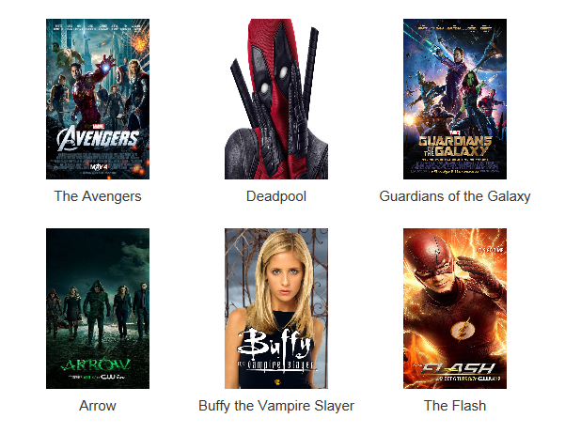

Choosing “comedy” genre:

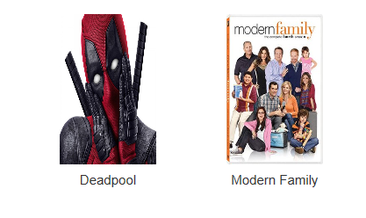

Choosing “fantasy” genre:

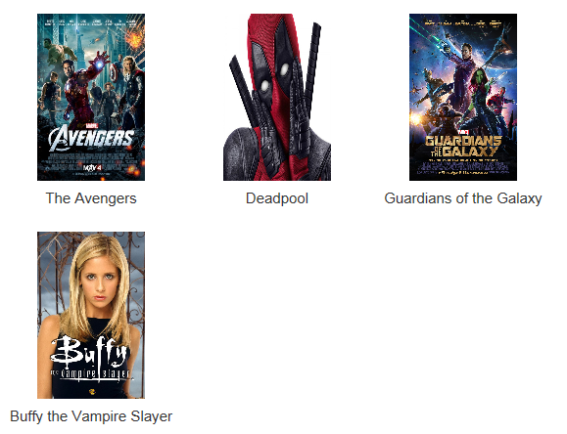

## Erroneous input for ‘categories’ array:

If the order is not followed properly, that is the categories array doesn’t match the order passed on to “webpagecreator.py”, the display is erroneous. It will work but the genre selection will not match the displayed movies.

categories = [**"comedy"**, **"action"**, **"drama"**, **"fantasy"**]  
  
action = [Avengers, Deadpool, GuardiansOfTheGalaxy, Arrow,Buffy, Flash]  
comedy = [Deadpool, ModernFamily]  
drama = [DarkKnight, Buffy, Arrow, Flash]  
fantasy = [Avengers, Deadpool, GuardiansOfTheGalaxy, Buffy]  
  
  
webpagecreator.create_genre_pages(categories, [action, comedy, drama, fantasy])

**Executing the code with erroneous order:**

Selecting “comedy” genre:

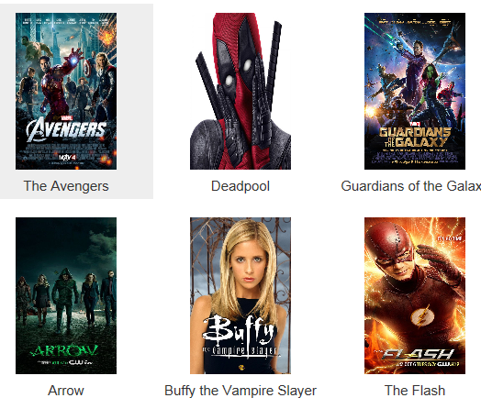

Selecting “action” genre:

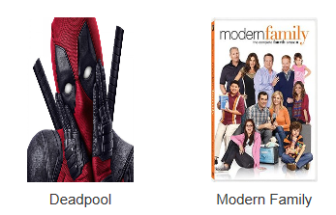

As can be seen, “action” genre displays the comedy one, while “comedy” genre displays the action one. Hence the importance of making sure that they are in the same order.